AHS REGION 14 FALL MEETING
SATURDAY, OCTOBER 6, 2018
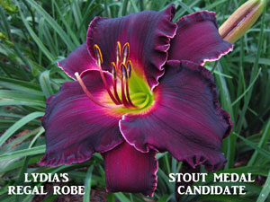
Hosted by the Meridian Daylily Club
GUEST SPEAKER: Bill Waldrop
Kennesaw Mountain Daylily Gardens
Marietta, Georgia 30064
REGISTRATION FEES: $25-single, $40-couple, $15-youth
Make checks payable to Meridian Daylily Club.
Mail check and registration form to:
Jeanie Kilpatrick, Registrar 282 Wilson Avenue DeKalb, MS 39328
Registration deadline is Thursday, September 27, 2018
AGENDA
8:30 a.m. Registration and plant tables open
10:00 a.m. Region 14 Business Meeting, Terese Goodson, Region 14 President presiding
10:30 a.m. Bill Waldrop, Kennesaw Mountain Daylily Gardens
11:30 a.m. Lunch
12:30 p.m. Bill Waldrop, Kennesaw Mountain Daylily Gardens
1:30 p.m. Announcements, Terese Goodson, President
Door Prizes
2:00 p.m. Plant Auction
3:00 p.m. Meeting Adjourned

